Castlewood Homeowners’ Association, Inc.

3420 Fairfield Ln.

Highland Village, TX 75077

October 10, 2024

Dear Homeowner,

You are hereby given notice that the annual meeting of the members of the Castlewood Homeowners’ Association, Inc., will be held on Tuesday, December 10, 2024, at 6:00 pm at the Castlewood Clubhouse located at 3420 Fairfield Ln., Highland Village, TX 75077.

**The purpose of this meeting is to elect (2) two board members.**

Returning your proxy/absentee ballot will help us meet quorum requirements and save the association the expense of calling a second meeting.

During the annual meeting on December 10, 2024, the board will outline 2024 accomplishments and goals for 2025. The annual meeting packet will be posted on the community website for your reference or if you are unable to attend the meeting, [www.castlewoodhoa.com](http://www.castlewoodhoa.com).

Please return your proxy/ absentee ballot no later than 5:00 pm on Friday, December 6, 2024. You may return the completed form in the following ways: scan the completed form and email it to the community manager at [jhansen@spectrumam.com](mailto:jhansen@spectrumam.com), drop it off at the onsite office during business hours, deposit it in the drop box at the onsite office, or return via mail to the address above.

Please remember that your annual assessments of $650 are due on January 1, 2025. Payments posted after the close of business on January 31, 2025, will be subject to a late fee and collection fees as defined in the HOA’s collection policy. These fees will continue to be assessed each month until assessments are paid in full. Watch your mailbox for the annual billing statement.

Payments are no longer accepted at the onsite office. The onsite office staff can assist you with logging in to your Spectrum account or registering your account for the first time.

Thank you and we look forward to seeing you at the annual meeting.

Castlewood Board of Directors

**2025 Budget Summary**

|  |  |
| --- | --- |
| **Expense Type** | **2025 Budget** |
| Maintenance | $16,300.00 |
| Utilities | $47,750.00 |
| Administrative | $53,691.00 |
| Contract Services | $74,490.00 |
| Parts & Supplies | $3,000.00 |
| Insurance | $16,000.00 |
| **Transfer to Reserve** | **$38,369.00** |
| **Total Expenses** | **$249,600.00** |

Total Properties in Castlewood: 384

2025 Annual Assessments: $650

Assessment Due Date: January 1, 2025

If you have any questions or would like to view a line-by-line budget summary, please contact the community manager at [jhansen@spectrumam.com](mailto:jhansen@spectrumam.com) or log into your Spectrum account.

**2024 Castlewood Board of Directors**

Mike Murphy/ President- Term expires December 2025

Amber Coddington/ Treasurer- Term expires December 2024

Melody Orrantia/ Secretary- Term expires December 2024

James Richter/ Director- Term expires December 2025

Manoj Thomas/ Director- Term expires December 2025

**2025 Board of Director Candidate Profiles**

**Amber Coddington- current treasurer and candidate for the Board of Directors**

Amber Coddington is no stranger to most of you.  Amber is very involved in a variety of clubs and groups in the community and has a busy family of six. Amber is the proud mom to Ashley, Trevor, Caleb, and Hannah. Not only is she involved with a wide variety of activities right here in Castlewood, but she also runs National Computer with her husband Gerald. Amber holds a bachelor’s degree in political science and a master’s degree in early childhood education.

Amber serves in several roles in various organizations including the Castlewood Dragons Swim Team, Briarhill Band and Orchestra booster clubs, Marcus Band & Orchestra, and Girl Scouts. She is also an administrator for the Castlewood Moms Facebook group.

Amber has served on the Castlewood BOD as the treasurer for the past ten years. It is clear she is dedicated to the success of the community and the objectives of the HOA and will continue to work to keep Castlewood a great place to live.

**Melody Orrantia**- **current secretary and candidate for the Board of Directors**

Melody is a Castlewood resident since 2000 and has served the past two years as Secretary of the Castlewood HOA Board of Directors. She and her husband Dan raised their daughter Hayley in Castlewood. Hayley is best known for playing the role of “Erica Goldberg” for 10 years on ABC Television's ***The Goldbergs*** and is an accomplished singer/songwriter.

Melody has been a realtor for the past 8 years and has represented many Castlewood owners in the sale of their home. Along with her sister, Melody also owns Grand Fiori which handcrafts and rents giant standing flowers for weddings, parties and special events.

Prior to becoming a realtor, Melody spent many years as an executive at one of the world’s largest management consulting firms, Accenture, where she provided strategy consulting to several Fortune 100 companies. Throughout her career, she has served in a leadership capacity in several nonprofit organizations including the United Way and the Network of Executive Women.

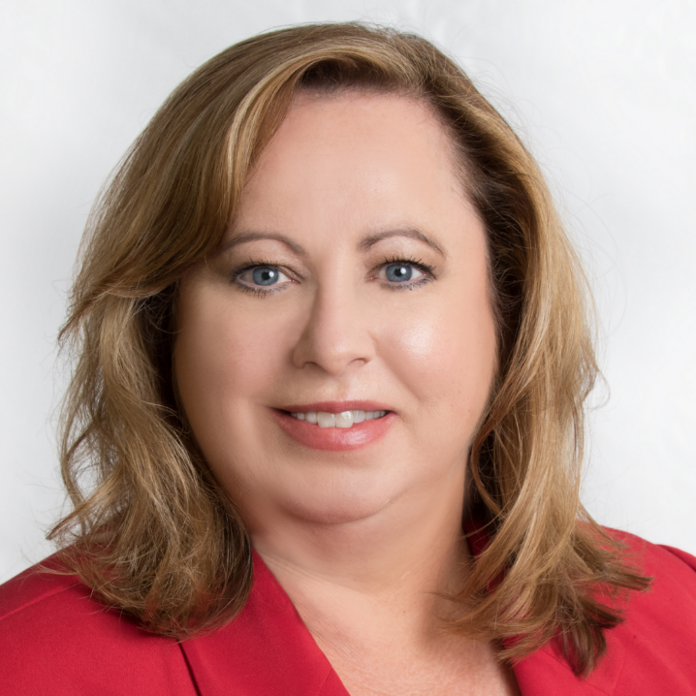

**Cameron Glass- candidate for the Board of Directors**

Since moving to Castlewood in May 2023, Cameron Glass quickly got involved in serving the neighborhood through his work on the Architecture Committee. Over the past year, he worked with the committee to update and present the community’s revised design guidelines. Cameron and his wife, Megan, are raising their four children—Aidyn, Peyton, Owen, and Ellison— and have enjoyed taking part in the neighborhood’s activities and events.

Cameron Glass holds a leadership position at a prominent construction management firm, where he oversees large-scale, complex projects. His work focuses on strategic leadership, fostering collaboration, and supporting community development. With extensive experience managing multi-million-dollar initiatives, Cameron ensures projects are completed on time, within budget, and to the satisfaction of diverse stakeholders. His 24-year career in management has equipped him with the skills necessary to address community needs with efficiency and foresight.

In addition to his professional background, Cameron is passionate about giving back and helping to shape Castlewood’s future. His goal as a board member is to maintain and enhance the sense of community that makes Castlewood a sought-after community to live in, while addressing concerns related to our community's infrastructure, development, and neighborhood engagement.

Castlewood Homeowners’ Association, Inc.

2024 Annual Meeting Proxy/ Absentee Ballot

***Please sign, date, and return before 5:00 pm on Friday, December 6, 2024.***

To vote by **proxy,** select Option 1 or Option 2. For your proxy to be valid, the owners’ name, signature, date, and property address must be filled in.

To vote by **absentee ballot** select option 3 at the bottom of the form. For your ballot to be valid the owners’ name, signature, date, and property address must be filled in.

**_____ Option #1** - ___________________________ *(name of someone who will attend the meeting on your behalf)* will attend and represent me with the full power to vote and act formed in the same manner, to the extent and with the same effect as if I were personally present.

**_____Option #2** - This proxy is to be used for quorum purposed only.

Unless terminated sooner, this voting instrument shall terminate automatically upon the final adjournment of the Annual Meeting for which it was given.

Owner’s Name (Printed)__________________________ Signature of Owner _______________________________

Owner’s Property Address____________________________________________________________ Date ________

To vote by absentee ballot, complete option #3 ONLY. For the ballot to be valid, the owners’ name, signature, property address, and date must be filled in.

**_____ Option #3**- Vote by Absentee Ballot. You may submit an absentee ballot and later choose to attend the meeting in person, in which case any in-person vote will prevail.

**Please vote for 2 (two) Board Members by selecting 2 (two) boxes below.**

|  |  |
| --- | --- |
|  | Amber Coddington |
|  |  |
|  | Melody Orrantia |
|  |  |
|  | Cameron Glass |
|  |  |
|  | Write-in |

________________________________________

Owner’s Name (Printed)__________________________ Signature of Owner ________________________________

Owner’s Property Address ____________________________________________________________Date__________